**Git with Netbeans Instructions:**

1. First, you need to have a Git account.

1. Open Netbeans

2. Navigate to “Team” -> “Git” -> “Clone Project”, it will come out a dialog.

3. At step one, please input <https://github.com/Rianddy/CourseRegistration> as the repository URL, your username and password.

4. At step two, please select the “master brunch” for now. Right now, we didn’t divided into groups. Maybe later, we will create several brunches for different groups to work and then merge with “master brunch”. If you have any problem with understanding brunch, please check it on Google because it can be really complicated.

5. At step three, you don’t have to change anything except remote name (change it to your name).

6. Then a dialog will come out and ask you whether “you want to open the project”. Select “Open”.

7. Now you already have the local same repository as the repository in Git. You can right click the project “CourseRegistration” -> “Git” -> “Repository” -> “Repository Browser”. There will be a browser on the center of the bottom. You can check the difference between local brunch and remote brunch. (When you edit something on local brunch, it won’t change anything of remote brunch.)

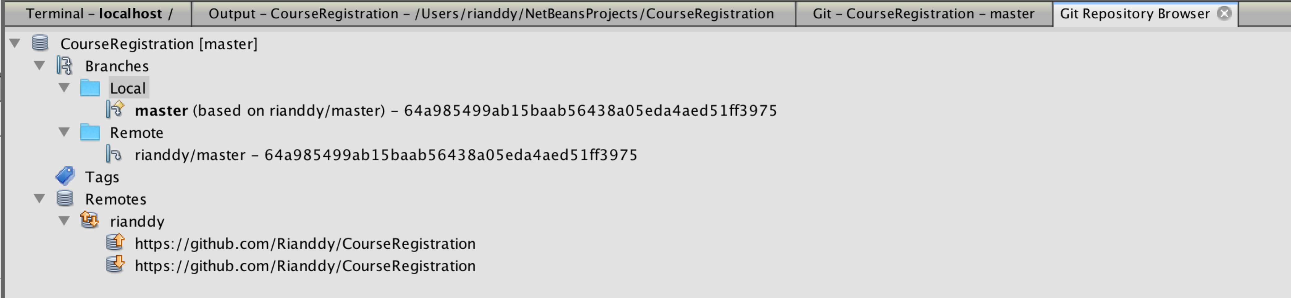

8. Right now, you cannot commit any change to the main repository because I didn’t give you the privilege to do this. And I still didn’t figure out how to manage the different privileges.

*9. Strongly recommend “http://git-scm.com/book/en/v2/Git-Branching-Branches-in-a-Nutshell” to learn the brunch. Trust me, this will be really useful for you to understand Git’s efficient way and version control.